**Create a bullet chart with Category and Segment dimensions and Sales measures.**

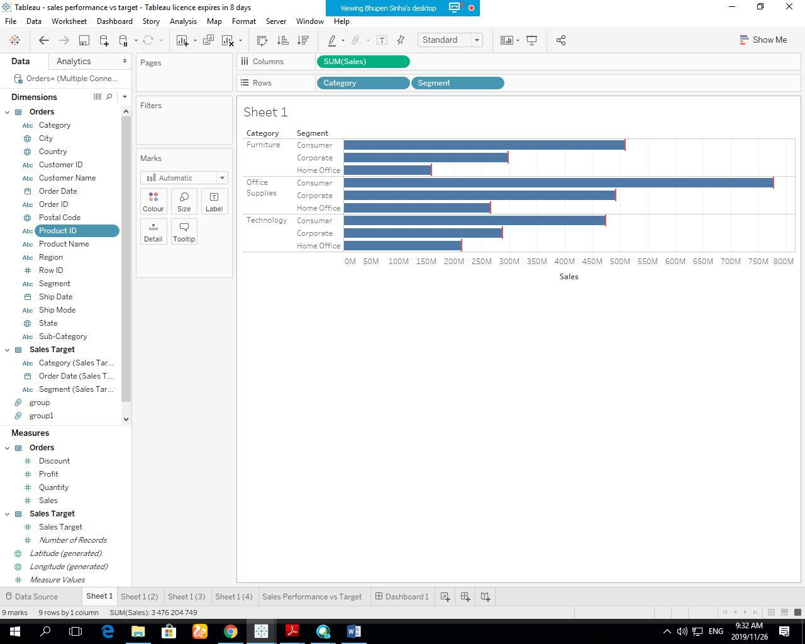

**Blend the data with the Saved Sample - Sales Target data set to bring in the Sales Target measure.**

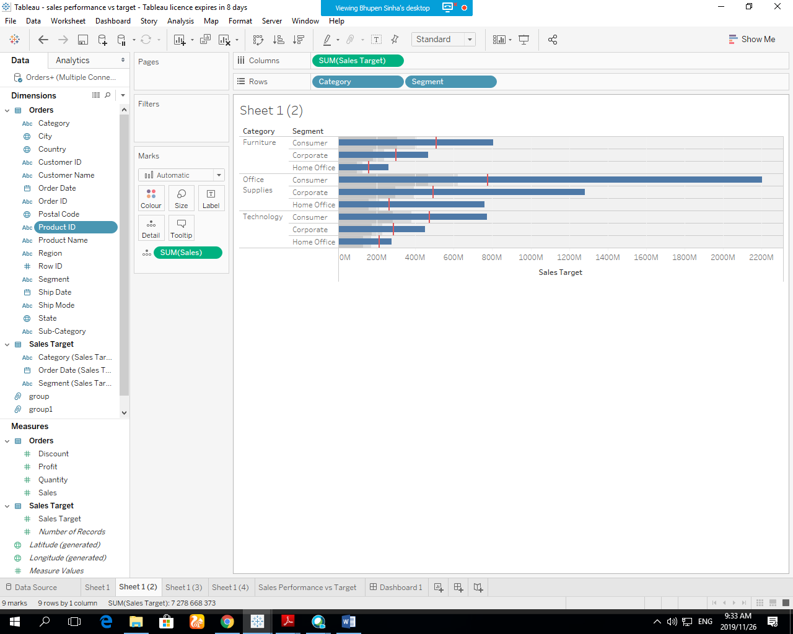

**Color code the chart to identify Categories and Segments that are above or below target.**

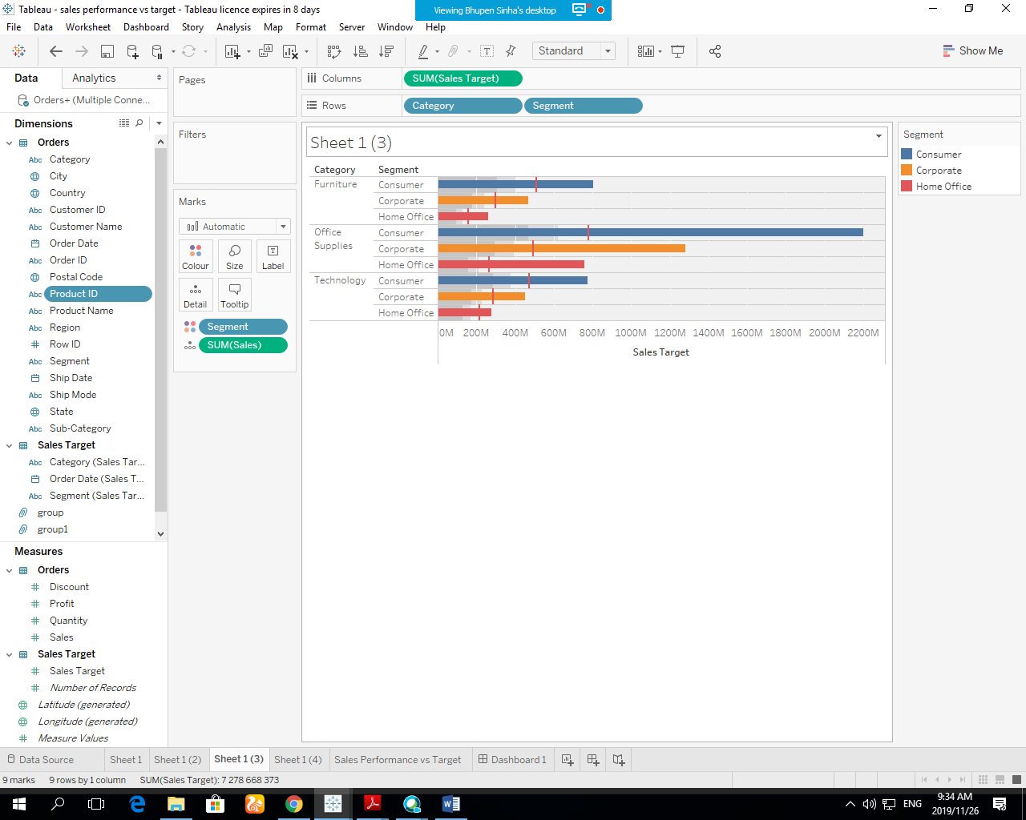

**Add the year of sales to the view to identify trends and outliers.**

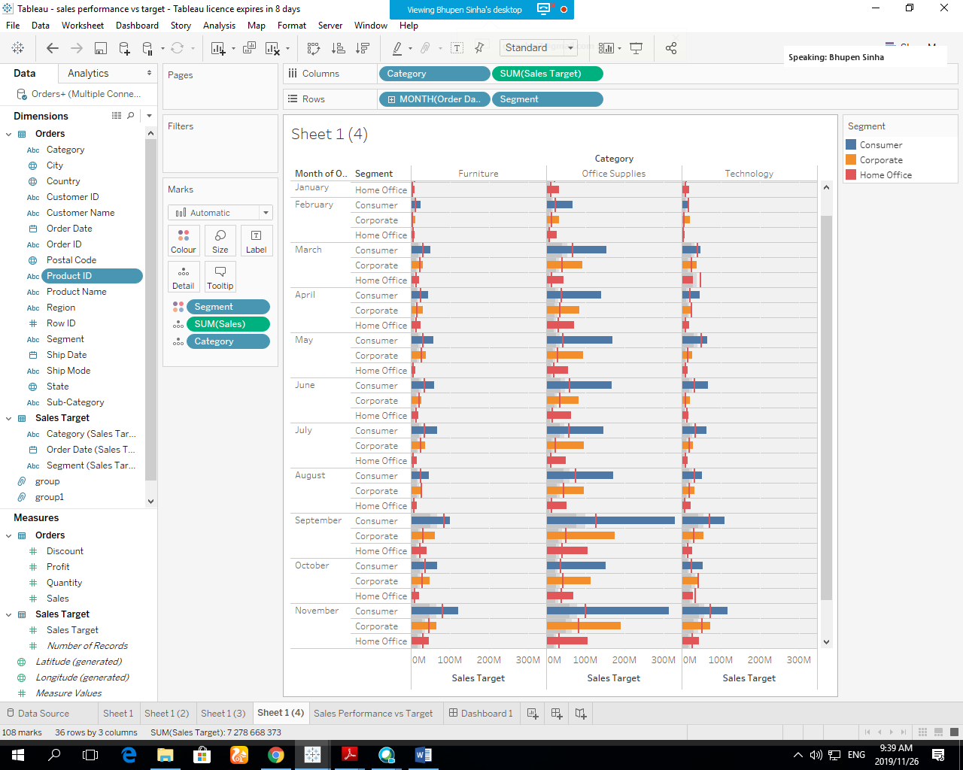

**Add a filter so that the user can select one, more than one, or all years.**

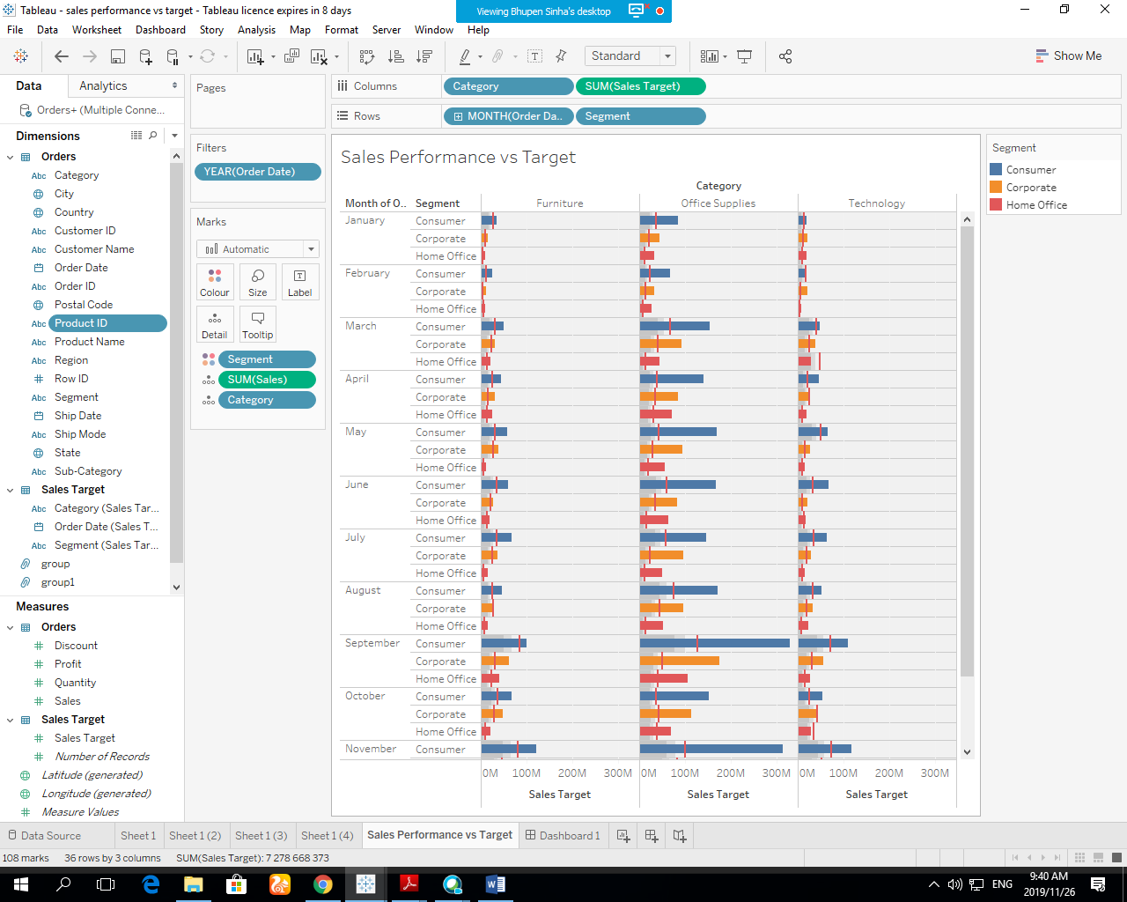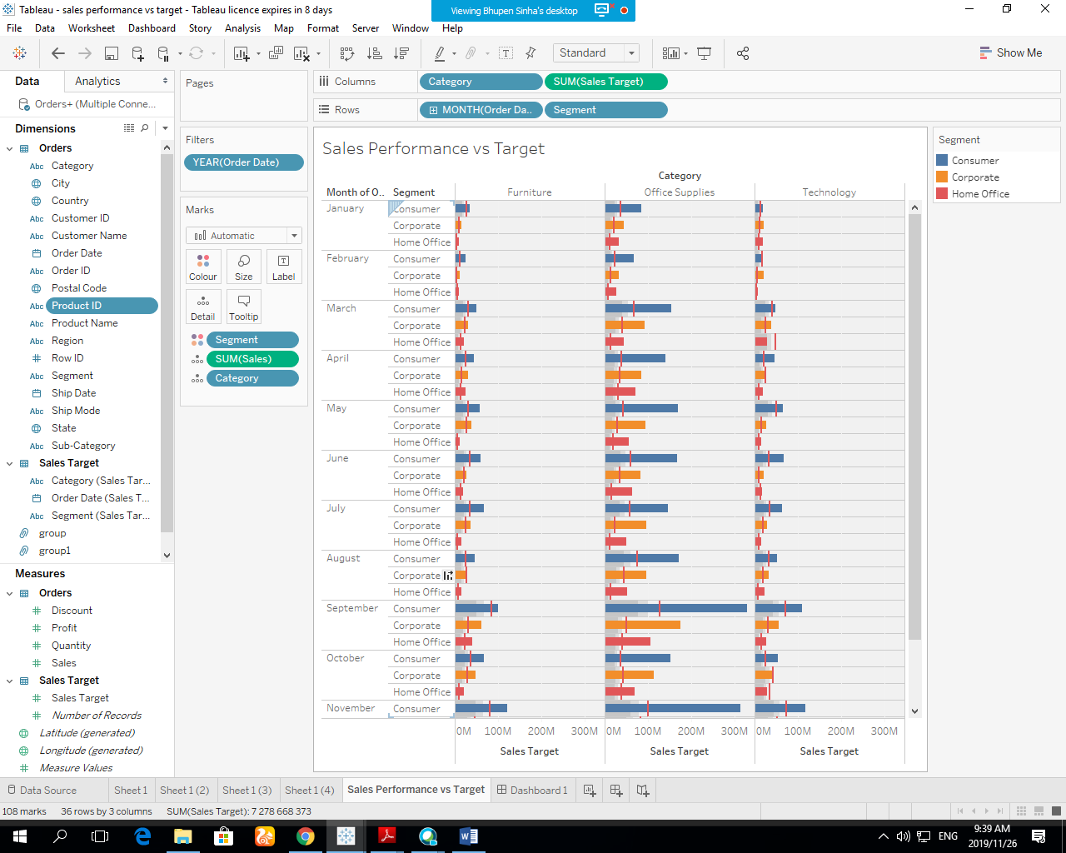

**Create a dashboard with this view.**

